Tutorial 06 Recursion

1. Consider the following Python program:

**def** main():

y = foo( 4 ) bar( 2 )

**def** foo( x ):

**if** x % 2 != 0:

**return** 0

**else**:

**return** x + foo( x-1 )

**def** bar( n ):

**if** n > 0:

bar( n-1 ) print( n )

main()

1. What is the output of the program?

1

2

1. Draw the recursive call tree for the program

 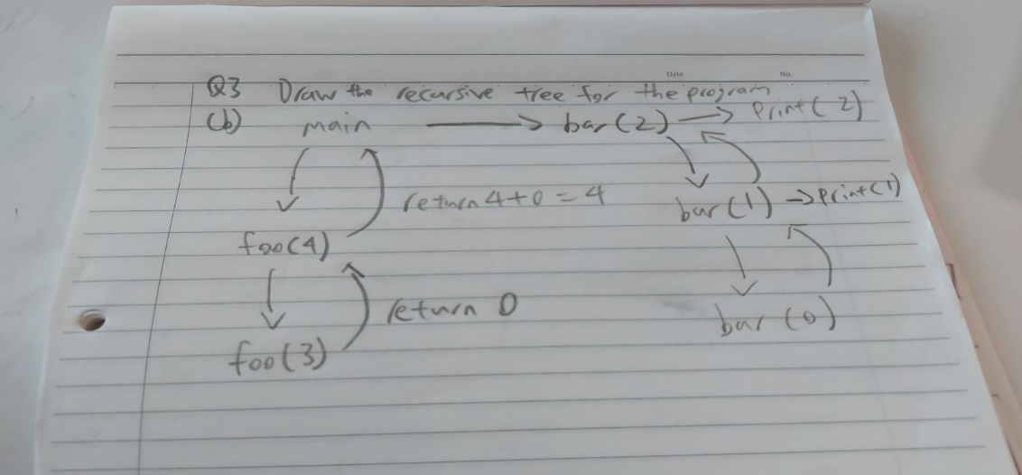



***-- End of Tutorial --***